PRESS RELEASE
10.07.13

Allen Sides and his Focusrite are Number One for Josh Groban
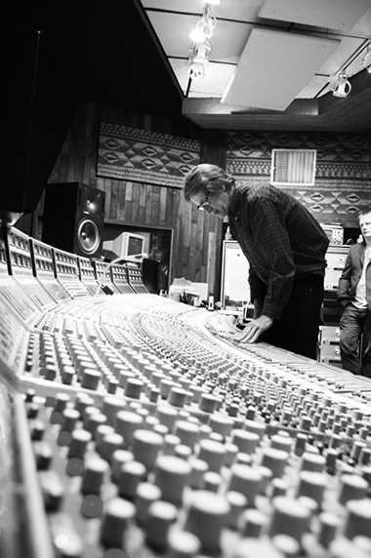Allen

It's no exaggeration that Allen Sides is one of the most important figures in the recorded music industry - he operates Ocean Way Recording, a group of studios regarded as being amongst the best facilities in the world, and is himself a five-time Grammy-award winning engineer/producer. He's worked on hundreds of records by the likes of Phil Collins, Green Day, Eric Clapton, Joni Mitchell, Frank Sinatra, Ray Charles and Frank Zappa, and continues to work successfully on new albums. One such record is the latest by singer-songwriter Josh Groban - 'All that Echoes', which recently reached number one on the Billboard chart.

Allen recorded the majority of the record using his Focusrite Studio Console, and we caught up with him to talk vintage Focusrite and recording in the modern age:
What's your connection to Focusrite, Allen?
"Phil Dudderidge has been a good friend for many years; he and his wife are incredibly delightful and we've always had a great rapport over the years. We put that console in a while ago now…20 years or so…something like that."
To what extent did the Focusrite console play a part in the record?
"I would say that probably 80% of the record was recorded on that console and we mixed the album on that console. We were using the Focusrite mic-pres and EQs, although they are quite custom now, but no compression, which is an intriguing point about this record. Actually, when Rob (Cavallo - A&R/Producer and Chairman of Warner Bros. Records, who produced the record) played it to the A&R folks across the world, they were asking "why is it so punchy?". Because everyone's so used to hearing compression, they're not used to that kind of impact. Rob says it's almost like the 'new sound' - well, it's not the new sound, it's the sound we used to have years back when everything sounded great! This allowance of dynamic range is refreshing the music industry. It even tends to sound better on radio because it's got punch before it's compressed at broadcast, compared to most records now which have no punch left by that stage.
Can you tell us a little about the console?
"It's a 64 channel desk with 12 stereo echo returns, which is big, but we do some big projects - large orchestras and so on. We keep ours in immaculate condition - every cap etc has been replaced to keep it working perfectly. Even with Josh, we did it live - we'd have Josh singing live with a full rhythm section; a harp, a violin and a cello to figure out parts as we went along; maybe a couple of guitars, bass, drums, keyboards - as we cut the tracks we had a lot of instruments on this thing!"
How long did it take to make the record?
"When we started on it, we just wanted to get in and get it done because of Josh's busy touring schedule. So we spent three months on-and-off, and recorded about 21 songs. "
What's new in the album-recording world?
"A few things come to mind:
- Most of the really big mixers are still mixing on analogue consoles, but I hear more recently that A&Rs are demanding more mixes to be in the box so that they can get in and change things;
- We recorded everything at 96k - this is a standard for me and we don't do anything at 48k anymore, because when you're recording, especially things that are subtle, you get much more resolution for low-level material and it sounds more open and airy. As I'm mixing in an analogue domain, I want the highest source resolution material.
- When we mastered this record, we actually ended up actually dropping the level because we were trying to get as much range as we could!"

Contact: Hannah.bliss@focusrite.com (US)
Will.evans@focusrite.com (UK)

